**DP2 2020-2021**

Workgroup Report

June Group #4

Repository

<https://github.com/rodddella/Acme-One/>

Members

* Guillermo Diz Gil
* Francisco Rodríguez Pérez
* Carmen María Muñoz Pérez
* George Laurentiu Bogdan

Tutor

* Rafael Corchuelo Gil

Table of contents

Summary 1

Recruitment 2

Members 3

Guillermo Diz Gil 3

Francisco Rodríguez Pérez 4

Carmen María Muñoz Pérez 5

George Laurentiu Bogdan 6

Responsibility agreement 7

# Summary

This document contains a description of how the team members have been recruited, as well as a personal information sheet for each member. In addition, it contains a formal agreement in which all members of the group commit themselves to carry out the work of the subject.

Recruitment

This working group was formed at the beginning of the course. Its members are capable, qualified workers with a great sense of responsibility. Our experience has been forged by working together on various projects throughout our academic career, as well as with the development of personal projects. We have a great deal of trust in each other, which allows us to carry out large-scale work efficiently and effectively.

# Members

## Guillermo Diz Gil

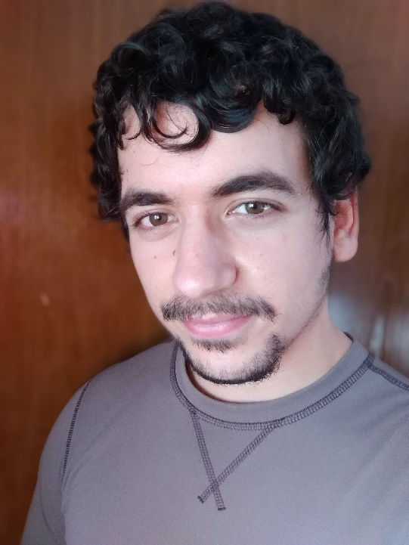

##### Contact data

Corporate e-mail: [guidizgil@alum.us.es](mailto:guidizgil@alum.us.es)

##### Roles

* *Manager:* Person in charge of overseeing tasks and creating and maintaining the project repository.
* *Developer:* Person in charge of creating development configuration, customizing the starter, implementing features, and performing informal testing.
* *Analyst:* Person in charge of elicit requirements, create a domain model and

define features.

* *Tester:* Person in charge of doing functional, performance and acceptance testing.

##### Performance assessment

He has taken part in the deliverable in the way we expected. He worked well.

## Francisco Rodríguez Pérez

##### 

##### Contact data

Corporate e-mail: [frarodper4@alum.us.es](mailto:frarodper4@alum.us.es)

##### Roles

* *Developer:* Person in charge of creating development configuration, customizing the starter, implementing features, and performing informal testing.
* *Analyst:* Person in charge of elicit requirements, create a domain model and

define features.

* *Tester:* Person in charge of doing functional, performance and acceptance testing.

##### Performance assessment

He has taken part in the deliverable in the way we expected. He worked well.

## Carmen María Muñoz Pérez

##### 

##### Contact data

Corporate e-mail: [carmunper1@alum.us.es](mailto:carmunper1@alum.us.es)

##### Roles

* *Developer:* Person in charge of creating development configuration, customizing the starter, implementing features, and performing informal testing.
* *Analyst:* Person in charge of elicit requirements, create a domain model and

define features.

* *Tester:* Person in charge of doing functional, performance and acceptance testing.

##### Performance assessment

She has taken part in the deliverable in the way we expected. She worked well.

## George Laurentiu Bogdan

##### 

##### Contact data

Corporate e-mail: [geobog@alum.us.es](mailto:geobog@alum.us.es)

##### Roles

* *Developer:* Person in charge of creating development configuration, customizing the starter, implementing features, and performing informal testing.
* *Analyst:* Person in charge of elicit requirements, create a domain model and

define features.

* *Tester:* Person in charge of doing functional, performance and acceptance testing.

##### Performance assessment

He has taken part in the deliverable in the way we expected. He worked well.

# Responsibility agreement

We, group 4 of DP2, composed of Guillermo Diz Gil, Francisco Rodríguez Pérez, Carmen María Pérez Muñoz and George Laurentiu, having read, understood and accepted the organization and evaluation of the course, hereby declare to work together in order to achieve the grade A, agreed by simple majority.

In the event that a member of the group does not perform adequately, he/she will be expelled from the group, which will result in the failure of the course. Failure to perform adequately is defined as:

- Failure to perform the assigned tasks in a sprint, provided that these form a reasonable load for a group member.

- Repeatedly provoking disputes or unrest in the group, preventing the achievement of a common agreement.

On the ninth day of June, in Seville, signed by the interested parties.

|  |  |
| --- | --- |
| Guillermo Diz Gil | Francisco Rodríguez Pérez |
| Carmen María Muñoz Pérez | George Laurentiu Bogdan |